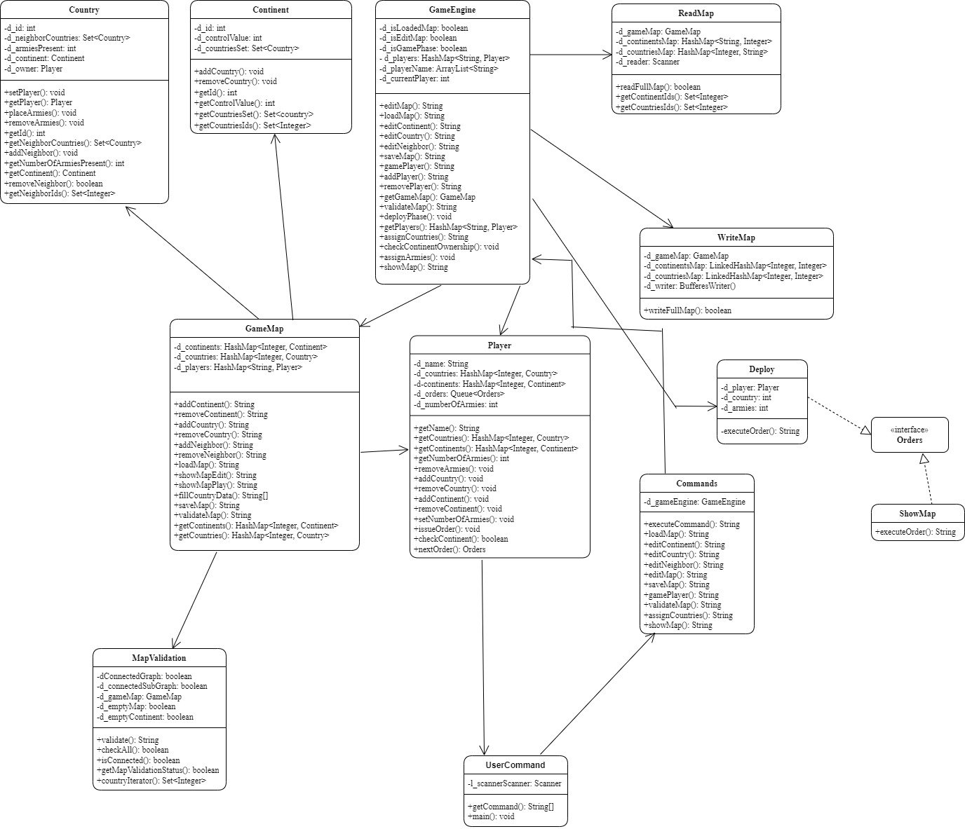

**Description:**

**Class Commands:**

This class will execute all commands by user which are fetched from UserCommand Class.

**Class UserCommand:**

This class will get user commands and call execute in Commands Class.

**Class GameEngine:**

This class handles most part of the game. It is controller of the game and all the operations will execute from this class.

**Class Country:**

This class contains all details of country like ID, Continent, Neighbours, Owner, No. of Armies, etc.

**Class Continent:**

This class contains all details of country like ID, Control Value.

**Class Player:**

This class contain all details of player like name of player, ID, dominated Countries and Continents, No. of Armies, Orders etc.

**Class GameMap:**

This class will handle all the operations related to map like add/remove Countries and/or Continents, add/remove neighbors, load map, save map, etc.

**Class WriteMap:**

This class will write game map as text in map file.

**Class ReadMap:**

This class will read data from map file.

**Class MapValidation:**

This class will validate map which is created by user, according to rules of the game.

**Class Deploy:**

This class will deploy armies according to orders issued by the player.

**Class ShowMap:**

This class will execute show map command at any time in the game.

**Interface Orders:**

This interface provides structure for execute order.